1. Predicting customer churn is a critical task for businesses looking to retain their customers and improve their bottom line. To effectively address this objective, you can define specific objectives related to predicting customer churn as follows:

**1. \*Identify Potential Churners\*:**

- \*Objective:\* To accurately identify customers who are at risk of churning.

- \*Key Metrics:\* Precision, Recall, F1-Score, ROC AUC.

- \*Description:\* The primary goal is to develop a predictive model that can flag customers who are likely to churn in the near future. This allows the business to proactively take action to retain these customers.

**2. \*Predict Churn Probability:**

- \*Objective:\* To assign a churn probability score to each customer.

- \*Key Metrics:\* Probability distribution, calibration, Brier Score.

- \*Description:\* By estimating the probability of churn for each customer, the business can prioritize efforts and resources for retaining customers with higher churn probabilities.

**3. \*Understand Key Factors Contributing to Churn\*:**

- \*Objective:\* To identify the significant factors that influence customer churn.

- \*Key Metrics:\* Feature importance scores, statistical significance.

- \*Description:\* Analyze the data to uncover the underlying causes of churn. This helps in making informed decisions to address these factors effectively.

**4. \*Segmentation of Churners\*:**

- \*Objective:\* To categorize churners into distinct segments or groups.

- \*Key Metrics:\* Cluster analysis, demographic characteristics.

- \*Description:\* Group churned customers based on common characteristics or behaviors. This can lead to more tailored retention strategies for each segment.

**5. \*Lifelong Value Prediction\*:**

- \*Objective:\* To estimate the potential lifetime value of retained customers.

- \*Key Metrics:\* Customer lifetime value (CLV), revenue projections.

- \*Description:\* By understanding the expected value of retained customers, the business can make informed decisions about investment in retention efforts.

**6. \*Model Performance Evaluation and Improvement\*:**

- \*Objective:\* Continuously monitor and enhance the churn prediction model.

- \*Key Metrics:\* Model accuracy, AUC-ROC, model drift.

- \*Description:\* Regularly assess the model's performance and make necessary adjustments to ensure it remains accurate and relevant.

**7. \*Actionable Insights and Recommendations\*:**

- \*Objective:\* Provide actionable recommendations based on churn predictions.

- \*Key Metrics:\* Conversion rates of retention strategies.

- \*Description:\* Translate the predictive insights into concrete actions that the business can take to reduce churn, such as targeted marketing campaigns or personalized incentives.

**8. \*Monitoring Churn Reduction Progress\*:**

- \*Objective:\* Continuously track the impact of churn reduction efforts.

- \*Key Metrics:\* Churn rate, customer satisfaction scores.

- \*Description:\* Evaluate the effectiveness of retention strategies and adjust them as needed to achieve the desired reduction in churn.

By defining these specific objectives, you can create a structured approach to predicting customer churn, effectively retaining valuable customers, and improving overall business performance.

Customer Surveys:

Online Surveys: Use online survey platforms like SurveyMonkey or Google Forms to create surveys. Ask questions about demographics, preferences, and satisfaction.

In-Person Surveys: Conduct surveys in physical locations, events, or through phone calls to collect data from customers directly.

2. Website and App Analytics:

Implement tools like Google Analytics or Adobe Analytics to track customer behavior on your website or app. This provides insights into usage patterns, popular pages, and user demographics based on cookies and user accounts.

3. Customer Relationship Management (CRM) Systems:



Use CRM software like Salesforce or HubSpot to store and analyze customer data, including contact information, purchase history, and interactions.

4. Social Media Monitoring:

Monitor social media platforms for mentions and discussions related to your brand. Analyze the comments, posts, and messages to understand customer sentiment and preferences.

5. Email Marketing:

Analyze email campaign data to gather insights into customer engagement, such as open rates, click-through rates, and conversion rates.

6. Loyalty Programs:

Encourage customers to join loyalty programs. This allows you to collect data on their purchasing habits, preferences, and demographics in exchange for rewards.

7. Customer Interviews and Focus Groups:

Conduct one-on-one interviews or focus group sessions with customers to gather qualitative data on their experiences, needs, and preferences.

8. Social Media Surveys and Polls:

Utilize social media platforms to run surveys and polls that can help you gather data on customer preferences and opinions.

9. Transaction Data:



Analyze transaction records to understand purchase behavior, frequency, and spending habits of your customers.

10. Third-Party Data Sources:

- Purchase external data from data providers that can supplement your customer data with additional demographic information.

11. Mobile App Data:

- If you have a mobile app, collect data on app usage, including features used, time spent, and navigation patterns.

12. Chatbots and Live Chat:

- Implement chatbots or live chat support on your website to interact with customers. These interactions can provide valuable insights into customer queries and pain points.

13. Feedback Forms:

- Include feedback forms on your website, in emails, or on receipts to collect customer opinions and suggestions.

14. Purchase History:

- Analyze historical customer purchase data to identify trends and preferences.

15. Online Communities:

- Create online forums or communities where customers can discuss your products or services. This can provide valuable insights and foster engagement.

16. Geolocation Data:

- Use geolocation data (with proper consent) to understand where customers are located and tailor marketing efforts accordingly.

2.Ensure that you follow data privacy regulations such as GDPR or CCPA, and obtain explicit consent when collecting and storing customer data. Additionally, secure customer data to protect privacy and maintain trust with your customers.

1. Define Objectives and Audience:Understand the goals of your visualization.

Identify your target audience and their level of expertise.

2. Data Preparation:

Gather and clean the data related to churn and retention rates.

Ensure data accuracy and consistency.

3. Select Appropriate Visualization Types:

Choose visualization types that effectively convey the information. Some options include:

Line charts for trend analysis.

Bar/column charts for comparisons.

Pie charts for composition.

Heatmaps for correlation.

Scatter plots for relationship analysis.

Tables for precise data display.

Consider using drill-through or interactive features to provide more detailed information.

4. Identify Key Metrics:

Define the metrics that matter most, such as churn rate, retention rate, customer demographics, product usage, and customer feedback.

5. Create Dashboards:

Design a clear and organized dashboard layout.

Group related visualizations together.

Use consistent color schemes and fonts for clarity.

6. Visualize Churn and Retention Rates:

Create line charts to display trends in churn and retention rates over time.

Overlay these charts with markers indicating key events or changes that impacted rates.

7. Customer Segmentation:

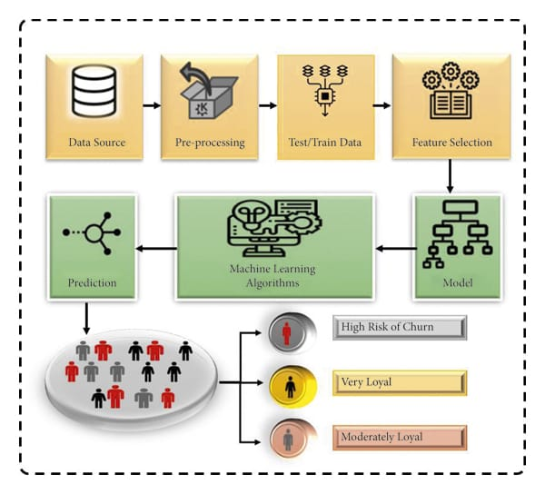

Use pie charts, bar charts, or tables to segment customers based on demographics, behaviors, or other relevant factors.

Highlight segments with high churn rates.

8. Identify Influencing Factors:

Utilize heatmaps or correlation matrices to show relationships between churn/retention rates and other variables (e.g., customer satisfaction scores, product usage, marketing spend).

Scatter plots can help visualize the relationship between two variables in more detail.

9. Predictive Analytics:

If applicable, include predictive analytics models that forecast future churn and retention rates.

Display predictions alongside historical data.

10. Interactivity:

Incorporate filters, drop-down menus, or slicers to allow users to interact with the data.

Implement tooltips for additional information when users hover over data points.

11. Storytelling:

Create a narrative around your visualizations to tell a compelling story.

Explain the insights, trends, and the impact of influencing factors on churn and retention rates.

12. Testing and Feedback:

Test the dashboard with a small group of users to gather feedback.

Iterate on the design based on user input.

13. Documentation:

Provide documentation on how to use the dashboard and interpret the visualizations.

14. Deployment:

Publish the dashboard on the IBM Cognos platform, making it accessible to the intended audience.

15. Monitoring and Updates:

Regularly update the dashboard with fresh data.

Monitor changes in churn and retention rates over time and adjust visualizations as needed.

3.By following this strategy, you can create effective visualizations in IBM Cognos that showcase the factors affecting churn and retention rates, enabling stakeholders to make data-driven decision Data Collection and Preprocessing:

Gather relevant data on customer behavior, interactions, and demographics.

Preprocess the data by handling missing values, outliers, and encoding categorical variables.

Feature Engineering:

Create meaningful features that can help the model distinguish between churned and non-churned customers. Some common features include:

Customer demographics (age, gender, location, etc.)

Usage patterns (frequency of product usage, time spent, etc.)

Customer history (purchase history, subscription length, etc.)

Customer support interactions (number of calls, complaints, etc.)

Sentiment analysis of customer feedback.

Data Splitting:

Split your dataset into training and testing sets to evaluate model performance.

Model Selection:

Consider using a variety of machine learning algorithms, including but not limited to:

Logistic Regression: A simple and interpretable model often used for binary classification tasks.

Decision Trees and Random Forests: Can capture complex relationships in the data.

Gradient Boosting (e.g., XGBoost, LightGBM): Good for improving predictive accuracy.

Neural Networks: Deep learning models can handle complex, high-dimensional data.

Model Training and Tuning:

Train your chosen models on the training data.

Optimize hyperparameters through techniques like grid search or random search.

Use techniques like cross-validation to ensure robust model performance.

Model Evaluation:

Evaluate models using appropriate metrics such as accuracy, precision, recall, F1-score, and ROC AUC. For churn prediction, you might want to focus more on recall to minimize false negatives (churned customers incorrectly classified as non-churned).

Consider using techniques like ROC curves or precision-recall curves for a more comprehensive view of model performance.

Feature Importance Analysis: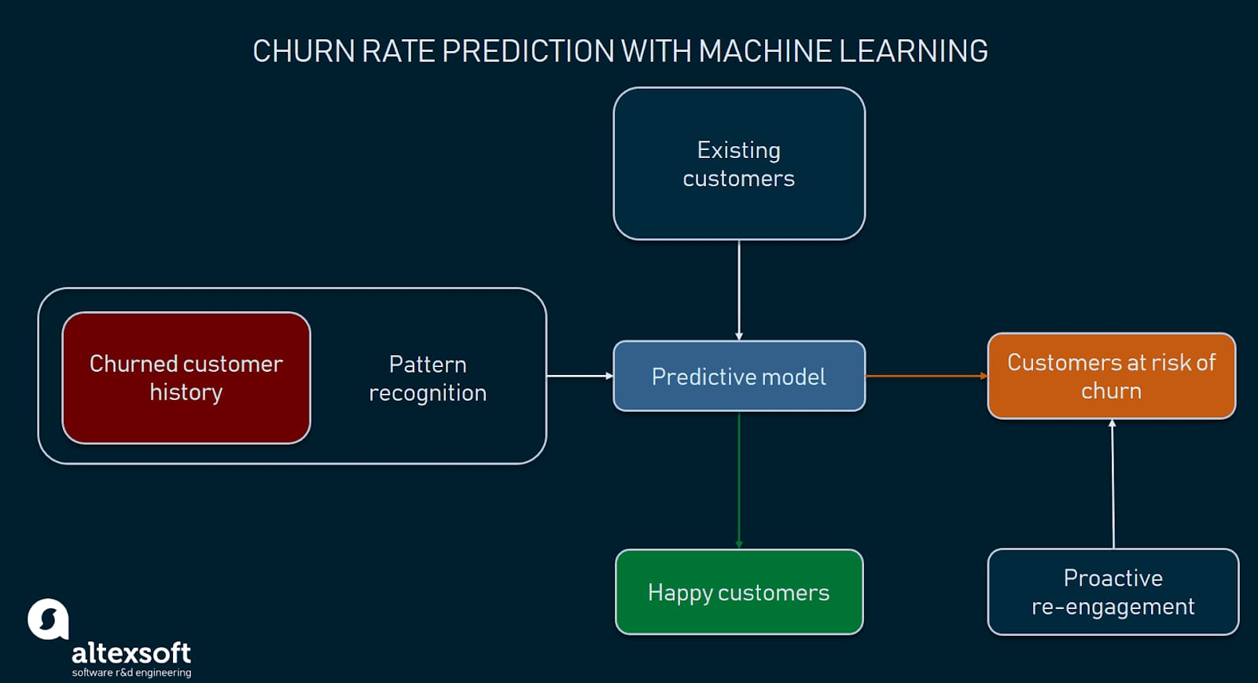

Determine which features are most important in predicting churn. This can help refine your feature set and improve model interpretability.

Ensemble Methods:

You can create ensemble models to combine the strengths of multiple algorithms. For example, combining a random forest with a gradient boosting model can often yield better results.

Regularization and Interpretability:

Consider using techniques like L1/L2 regularization to prevent overfitting.

Interpretability is important, especially if the model's predictions will inform business decisions. Techniques like SHAP values or LIME can help explain model predictions.

Deployment and Monitoring:

Once you've chosen the best model, deploy it in a production environment.

Continuously monitor the model's performance and retrain it periodically with fresh data.

Remember that the choice of algorithms and features should be driven by the characteristics of your data and the specific goals of your churn prediction task. It's also essential to iterate and refine your approach based on the real-world performance of your model and feedback from stakeholders.